

**Department of Engineering and Computer Science**

**Faculty of Software Engineering**

**BSSE-3(Afternoon)**

**Software Requirement Engineering**

**Assignment no 2**

**Name: JIBRAN NAEEM**

**Roll no: SP21111**

**Question:**

**What is use case, activity diagram & sequence diagram. Explain it with example and also draw their notations**

**Use case diagram**

A use case diagram is a graphical depiction of a user's possible interactions with a system. A use case diagram shows various use cases and different types of users the system has and will often be accompanied by other types of diagrams as well. The use cases are represented by either circles or ellipses.

* Specify the context of a system
* Capture the requirements of a system
* Validate a systems architecture
* Drive implementation and generate test cases
* Developed by analysts together with domain experts

USE CASE Notations:

* 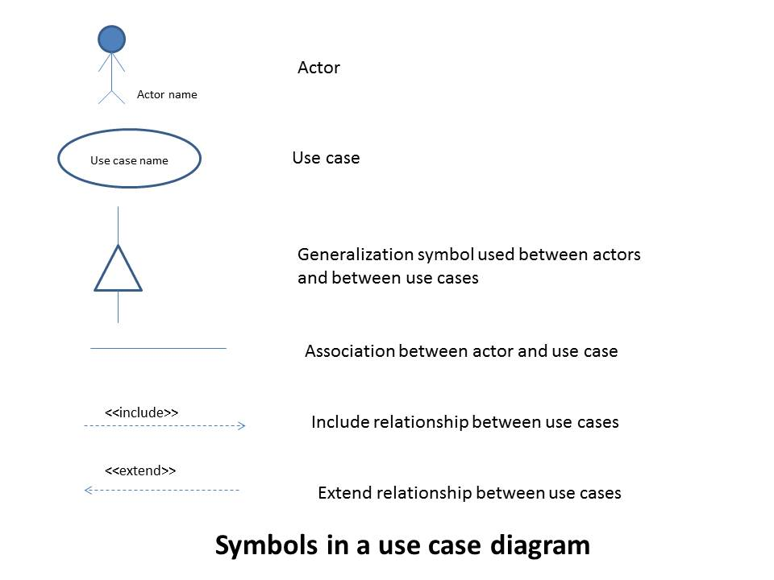

**Activity diagram**

An activity diagram **shows business and software processes as a progression of actions**. These actions can be carried out by people, software components or computers. Activity diagrams are used to describe business processes and use cases as well as to document the implementation of system processes.

Activity Diagram Notations:

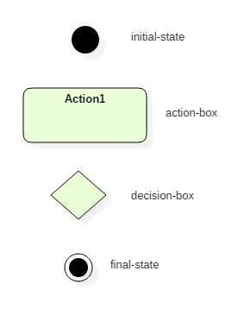

**Sequence diagram:**

A sequence diagram is a Unified Modeling Language (UML) diagram that illustrates the sequence of messages between objects in an interaction. A sequence diagram consists of a group of objects that are represented by lifelines, and the messages that they exchange over time during the interaction

Sequence Diagram Notations:



